**Feedback on latest «weighted_returns1.ipynb»**

**Benchmark Returns:  
Benchmark Returns are all correct**! The correct benchmark was selected and the correct figures are calculated! **Well Done.**

**Portfolio Returns:**Only 1 Portfolio Return is correct which is 242424. The others are wrong but the error is clear.  
Why Portfolio 242424 is correct is because this Portfolio invests 100% in EQ_CH:  
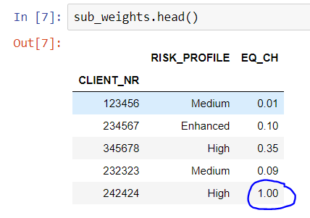

The reason the other Portfolios are wrong is it only takes the weight of EQ_CH into account. In the case of Portfolio 123456 it takes only 1% and multiplies this with EQ_CH. This in itself is correct but 99% are still missing.

The full weights for Portfolio 123456 are:  
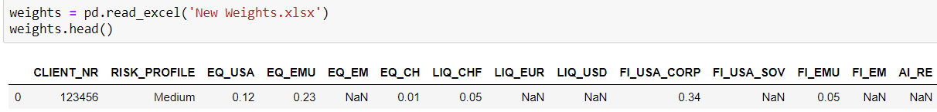  
Portfolio 123456 invests 0.12 in EQ_USA, 0.23 in EQ_EMU, 0.01 in EQ_CH, 0.05 in LIQ_CHF, 0.34 in FI_USA_CORP, 0.05 in FI_EMU, 0.11 in AI_HF and 0.09 in MIX. Then one must sum/add up all those weighted returns to come up with 100% weighted return.

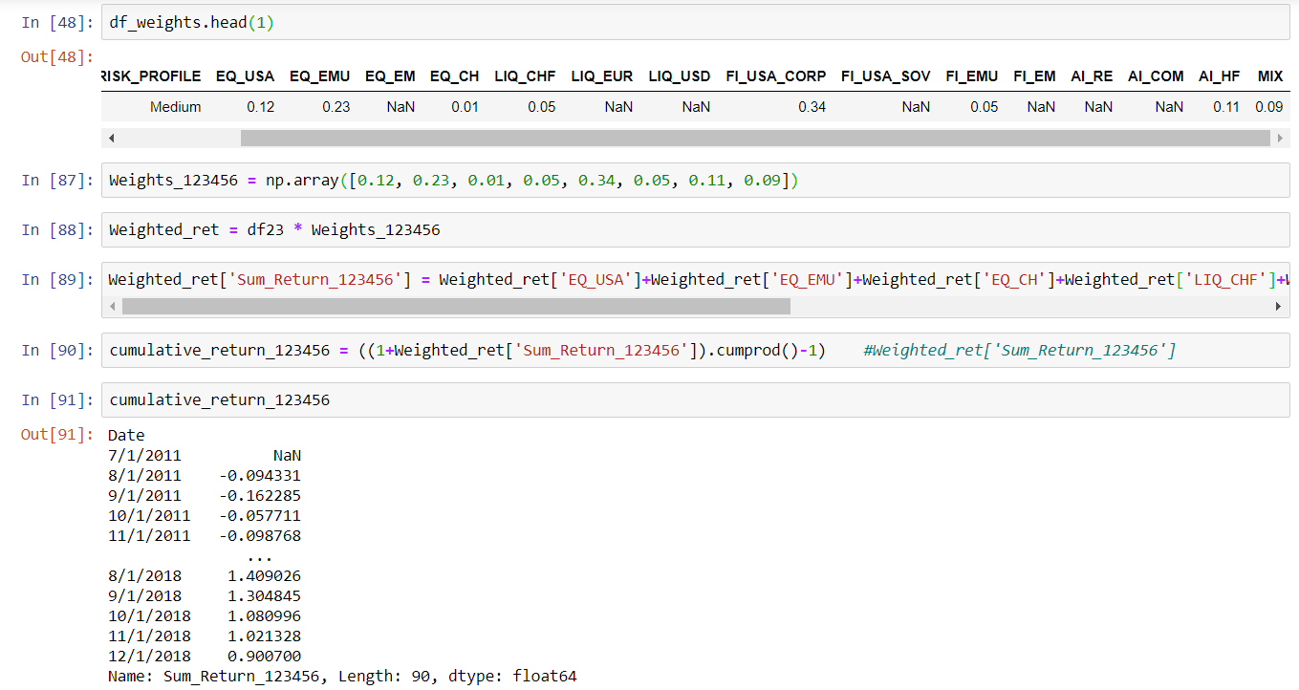

The cum return for portfolio 123456 should be 0.9007 or 90.07%.

I should have made this part more clear as that was developed in the weighted returns notebook that you had received. It checks where the the files df3.xlsx and «New Weights.xlsx» have the same column title to know which prices/returns.

**Please use df31.xlsx as a replacement for df3.xlsx**

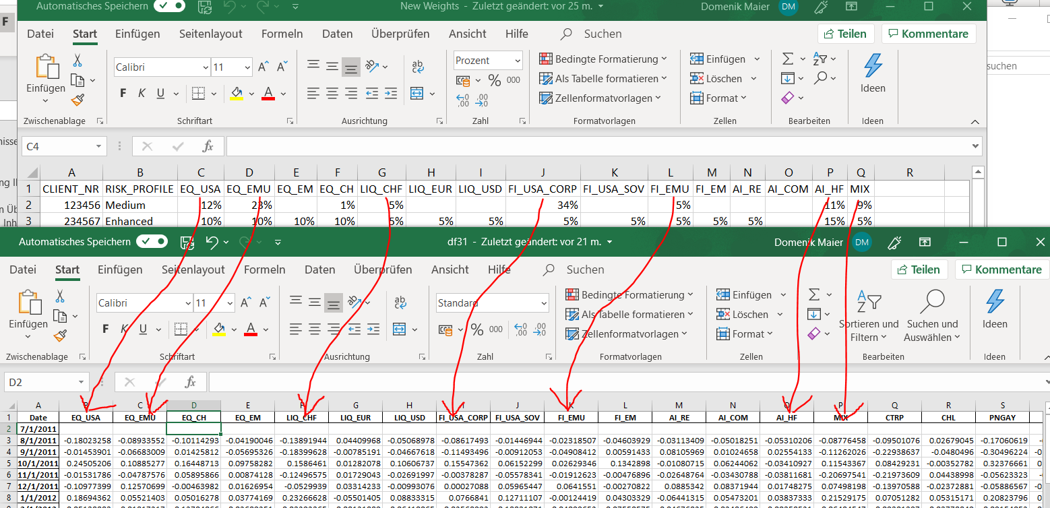

**Also Still to do :**

All plots must be saved as « client nr »+png so for example « 12345.png » or « 234567.png »  
Preferably all graphs are saved in a subfolder of where the ipynb is loacted. The subfolder is called « plots ».